Task 1: Delivery Time Statistical Profiler :
Build a Python program that computes descriptive statistics for a list of food delivery times and identifies the direction of skew in the data. Define a hardcoded list of at least 15 delivery time values (in minutes) that includes realistic values between 20–40 minutes and at least 3 outliers above 75 minutes. Calculate and print the mean, median, mode, variance, and standard deviation using Python's built-in statistics module. Determine whether the distribution is left-skewed, right-skewed, or approximately symmetrical by comparing the mean and median, and print a clearly worded conclusion.
Display a formatted summary report with each statistic labelled and aligned, so the output is readable without any additional context.

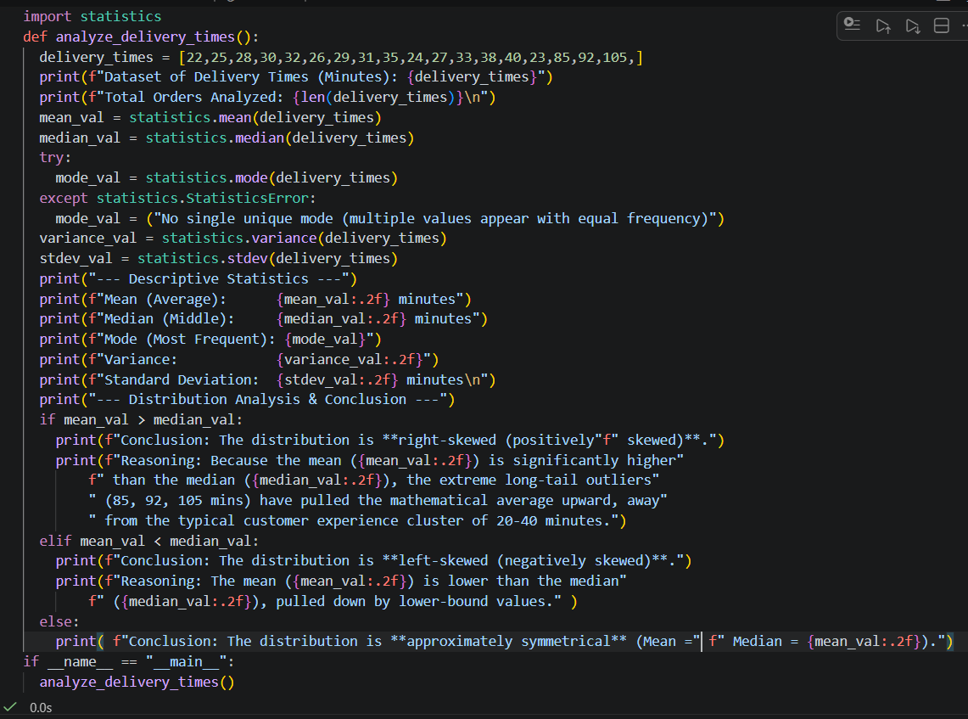

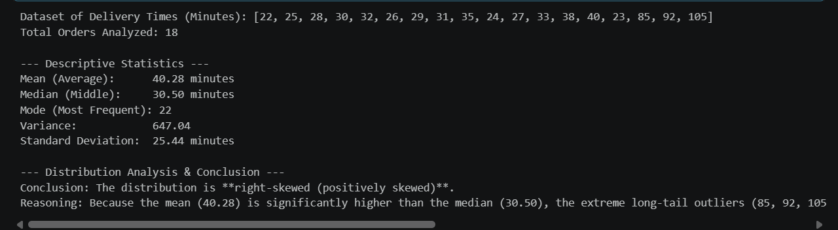

Task 2: Order Dataset Preprocessor Build a data preprocessing pipeline for a food delivery order dataset that handles missing values, applies one-hot encoding to categorical features, and scales numeric columns. Create a pandas DataFrame with at least 12 rows containing columns: order_id (int), restaurant_rating (float with at least 2 NaN values), payment_method (Cash / Card / Wallet), cuisine_type (Indian / Chinese / Italian / Fast Food), and order_value (float). Fill missing restaurant_rating values with the column mean and verify no NaN values remain using isnull().sum(). Apply one-hot encoding to both payment_method and cuisine_type using pd.get_dummies() and drop the original categorical columns from the DataFrame. Apply MinMaxScaler from sklearn.preprocessing to the restaurant _rating and order_value columns only, then print the final preprocessed DataFrame.

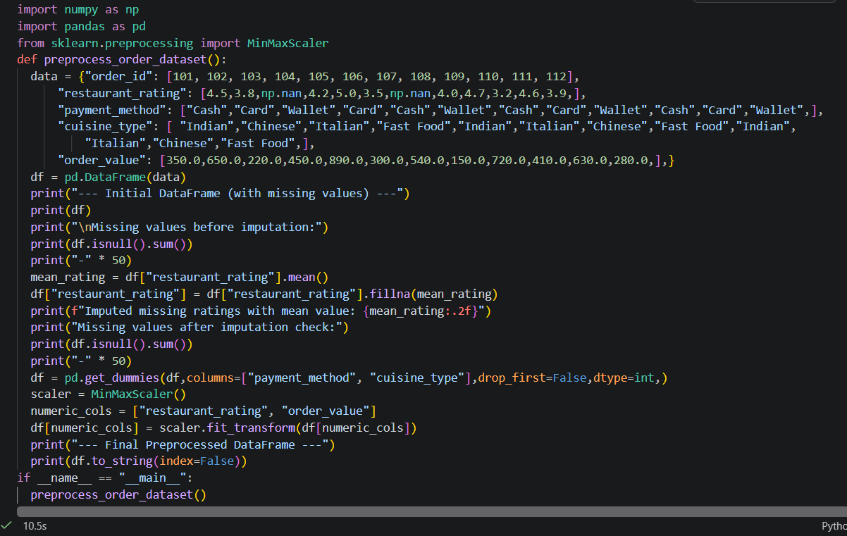

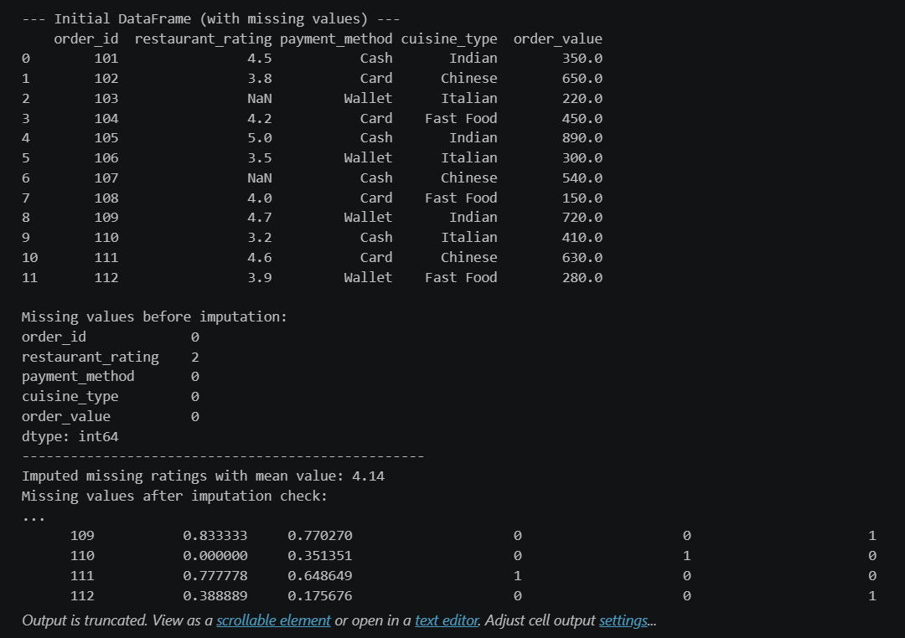

Task 3: Order Cancellation Classifier with Evaluation Train a Random Forest classifier to predict whether a food delivery order will be cancelled and evaluate the model using metrics suited for an imbalanced target class. Create or use a sample dataset of at least 120 records with features: order_value (float), delivery_distance_km (float), hour_of_day (int 0–23), and restaurant_rating (float), with a target column cancelled containing 1 (cancelled) and 0 (not cancelled) where approximately 20–25% are cancelled. Split the data into 80% training and 20% test sets using train_test_split with stratify=cancelled and random_state=42. Train a RandomForestClassifier with random_state=42, generate predictions on the test set, and print the full classification_report showing precision, recall, and F1-score for both classes. Compute and print the confusion matrix as a labelled 2×2 table identifying TP, TN, FP, and FN values explicitly in the output.
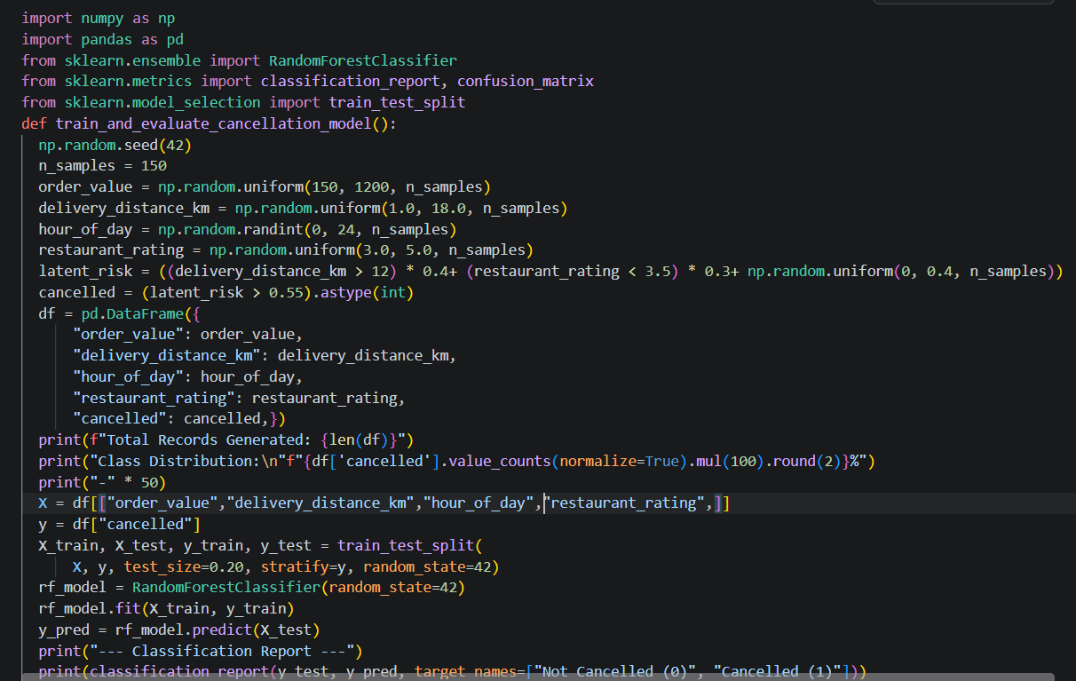
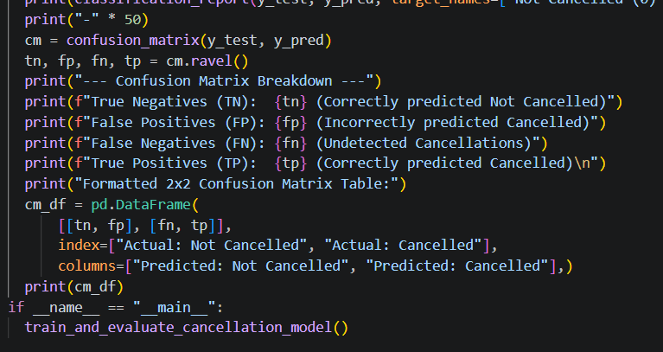

Task 4: Customer Segmentation with K-Means and PCA Visualisation Apply K-Means clustering to food delivery customer data, determine the optimal k using the Elbow Method, and produce a 2D cluster visualisation using PCA. Create or load a dataset of at least 150 customers with three features: monthly_orders (int), avg_order_value (float), and avg_delivery_rating (float 1.0–5.0). Apply StandardScaler to all three features before clustering. Run K-Means for k values from 2 to 9, record the inertia for each k, and plot the Elbow Method graph with k on the x-axis, inertia on the y-axis, and clear axis labels and a title.
Train a final K-Means model using the optimal k identified from the elbow graph and assign cluster labels to all customer records. Apply PCA to reduce the scaled data to 2 components, then produce a scatter plot with each cluster in a distinct colour, a legend identifying cluster numbers, and axis labels showing PC1 and PC2.

